IT Infrastructure & System Administration Internship
Submitted by
Utkarsh Srivastava
[EA2432251010355]

Under the Guidance of
Dr.G.Babu
(Assistant Professor, Directorate of Online Education)
in partial fulfilment for the award of the degree of

MASTER OF COMPUTER APPLICATIONS

DIRECTORATE OF ONLINE EDUCATION
SRM INSTITUTE OF SCIENCE AND TECHNOLOGY
KATTANKULATHUR- 603 203
November 2025

DIRECTORATE OF ONLINE EDUCATION
SRM INSTITUTE OF SCIENCE AND TECHNOLOGY
KATTANKULATHUR – 603 203
BONAFIDE CERTIFICATE
This Internship report titled IT Infrastructure & System Administration
by Utkarsh Srivastava [EA2432251010355] who
carried out the Internship Work under my supervision along with the company mentor.
Certified further, that to the best of my knowledge, the work reported herein does not form any
other internship report or dissertation based on which a degree or award was conferred on an
earlier occasion on this or any other candidate

ACKNOWLEDGEMENTS
We express our humble gratitude to Dr C. Muthamizhchelvan, Vice-Chancellor,
SRM Institute of Science and Technology, for the facilities extended for the project work and his continued support. We extend our sincere thanks to Director DOE, SRM Institute of Science andTechnology, Prof. Dr Manoranjan Pon Ram, for his invaluable support. SRM Institute of Science and Technology, for her support throughout the project work. We want to convey our thanks to Programme Coordinator Dr. G. Babu, Directorate of online Education, SRM Institute of Science and Technology, for their inputs during the project reviews and support. Our inexpressible respect and thanks to my guide, Dr G.Babu., Assistant Professor & Program Coordinator Directorate of online Education, SRM Institute of Science and Technology, for providing me with an opportunity to pursue my project under her mentorship.
He provided me with the freedom and support to explore the research topics of my
interest. His passion for solving problems and making a difference in the world has always been inspiring. We sincerely thank the Directorate of online Education, staff and students, SRM Institute of Science and Technology, for their help during our project. Finally, we would like to thank parents, family members, and friends for their unconditional love, constant support, and encouragement.

Utkarsh Srivastava
TABLE OF CONTENTS

Abstract ………………………………………………………………………………………. 5
Introduction ………………………………………………………………………………… 6
Analysis & Requirement ………………………………………………………………. 7
Problem Description ……………………………………………………………………. 8
Design Phase …………………………………………………………………………………9
Implement Phase ………………………………………………………………………….10
Testing Phase ……………………………………………………………………………….11
Tools & Technologies used ……………………………………………………………12
Conclusion …………………………………………………………………………………….13
Appendices ……………………………………………………………………………………14
Architecture Diagram …………………………………………………………………….15
Screenshots ……………………………………………………………………………………16
References ……………………………………………………………………………………….18

Abstract

This internship at Ansys Software Pvt Ltd provided valuable hands-on experience in the field of Cloud Infrastructure Support using AWS and Azure. The internship was aimed at enhancing my practical understanding of cloud computing concepts, system administration practices, and enterprise IT infrastructure management.
During the internship, I worked on provisioning and configuring virtual machines, managing cloud storage solutions, designing virtual networks, and setting up identity and access management policies. I was also involved in monitoring system performance, ensuring data security and compliance, and supporting backup and disaster recovery operations.
Through active collaboration with the IT Infrastructure team, I gained exposure to hybrid cloud environments, automation tools, and best practices in maintaining high availability and scalability. This internship not only strengthened my knowledge of AWS and Azure but also improved my problem-solving and technical support skills, which are essential for a career in Cloud Infrastructure and System Administration.

Introduction
Ansys Software Pvt Ltd is a global leader in engineering simulation software, delivering innovative solutions to help customers design .
and optimize products. The IT Infrastructure & System Administration team plays a critical role in enabling secure and scalable cloud services to
support global operations. My role as a System Administrator Intern included contributing to the setup, monitoring, and support of AWS & Azure resources.
This internship provided me with exposure to real-world enterprise cloud operations, including hybrid deployments and security management.

Analysis & Requirement
The Cloud Infrastructure Support internship required both technical and analytical skills for managing IT infrastructure in the cloud.
Skills & Knowledge Required:
- Networking fundamentals, Linux/Windows administration, and virtualization.
- AWS services such as EC2, S3, IAM, and VPC.
- Azure services such as Virtual Machines, Blob Storage, Virtual Networks, and Azure Active Directory.
Tools & Technologies Used:
- AWS Console, Azure Portal, CLI, and PowerShell.
- Cloud monitoring tools like AWS CloudWatch and Azure Monitor.
Requirements:
- High availability, secure authentication, scalability, disaster recovery, and cost efficiency were critical to the project.

Problem Description / Modules
The Cloud Infrastructure Support internship was divided into several modules to focus on specific aspects of cloud administration:
1. Identity & Access Management – Configuring AWS IAM and Azure Active Directory for secure authentication and role-based access.
2. Compute Management – Provisioning and maintaining AWS EC2 and Azure Virtual Machines.
3. Storage & Backup – Configuring AWS S3, Azure Blob Storage, and managing snapshots and backups.
4. Networking – Setting up VPCs, subnets, VPNs, security groups, and Azure Network Security Groups.
5. Monitoring & Logging – Implementing AWS CloudWatch and Azure Monitor for alerts and performance tracking.
6. Security & Compliance – Ensuring data encryption, patching, and compliance with company security standards.

Design Phase
In the design phase of the Cloud Infrastructure Support internship, the architecture and components of the cloud systems were defined. The design included:
1. Cloud Infrastructure Layout:
- AWS and Azure services were organized into Identity, Compute, Storage, and Networking modules.
- Logical and physical design diagrams were prepared using StarUML and AWS/Azure architecture icons.
2. Security Architecture:
- IAM roles and Azure AD groups were designed for secure access management.
- Policies were enforced for least privilege and MFA-based authentication.
3. Data Flow Design:
- Defined data transfer between S3, Blob, EC2, and Virtual Machines.
- Backup flow to ensure data redundancy and disaster recovery.
4. Monitoring Design:
- Dashboards and alarms were designed using AWS CloudWatch and Azure Monitor.

Implementation Phase
In this phase, the designed infrastructure was implemented using both AWS and Azure platforms.
1. AWS Implementation:
- Created IAM users, groups, and policies.
- Launched EC2 instances and configured S3 buckets.
- Set up CloudWatch for performance monitoring.
2. Azure Implementation:
- Configured Azure Active Directory for authentication.
- Created Virtual Machines and Azure Blob Storage containers.
- Implemented Azure Monitor for real-time metrics and alerts.
3. Automation:
- Used AWS CLI and Azure PowerShell scripts for automated provisioning.
- Configured scheduled backups using Lambda functions and Azure Automation.

Testing Phase
Testing was performed to ensure that all configured services and automation worked correctly.
1. Functional Testing:
- Verified IAM role permissions and access restrictions.
- Checked EC2/VM performance and connectivity.
- Tested backup and restore processes for data consistency.
2. Security Testing:
- Conducted penetration testing for open ports and unencrypted connections.
- Validated encryption in transit (TLS) and at rest (SSE, Azure Storage Encryption).
3. Load Testing:
- Used CloudWatch metrics and Azure Load Testing to check system performance under peak conditions.
4. Results:
- All modules passed security and performance benchmarks with minimal latency.

Tools and Technologies Used
During the internship, a range of tools and technologies were utilized for implementation and testing:
1. Cloud Platforms:
- Amazon Web Services (AWS)
- Microsoft Azure
2. Infrastructure Management:
- AWS Management Console
- Azure Portal
- AWS CLI
- Azure PowerShell
3. Monitoring & Logging:
- AWS CloudWatch
- Azure Monitor
4. Security & Compliance:
- AWS IAM
- Azure Active Directory
5. Design & Documentation Tools:
- StarUML (for diagrams)
- Microsoft Word and Excel (for reports)

Conclusion
The internship at Ansys Software Pvt. Ltd. offered a valuable opportunity to gain practical exposure to real-time Cloud Infrastructure Support using both AWS and Microsoft Azure platforms. Throughout the internship, I developed strong capabilities in cloud provisioning, identity and access management, system monitoring, data protection, and infrastructure automation.
This experience enabled me to understand how enterprise-level IT environments operate, including hybrid cloud management, security governance, backup strategies, and performance optimization. Working closely with the IT Infrastructure Team strengthened my problem-solving abilities, improved my technical confidence, and provided a deeper understanding of cloud operations and system administration best practices.
Overall, this internship was instrumental in enhancing both my technical knowledge and professional readiness. The hands-on tasks, real-time troubleshooting, and exposure to enterprise tools have helped me build a strong foundation for a future career in Cloud Infrastructure, DevOps, or Senior System Admin.

Appendices

Appendix A – Tools and Technologies Used
- Cloud Platforms: AWS, Microsoft Azure
- Compute Services: EC2, Azure Virtual Machines
- Storage Services: S3, Azure Blob Storage
- Identity Management: IAM, Azure Active Directory
- Monitoring Tools: AWS CloudWatch, Azure Monitor
- Automation Tools: AWS CLI, Azure PowerShell
- Networking: VPC, Subnets, NSGs, Route Tables
- Backup & DR Tools: AWS Backup, Azure Recovery Services Vault

Appendix B – AWS Tasks Performed
- Created and managed IAM users, groups, roles, and policies
- Provisioned EC2 instances and configured security groups
- Designed and configured S3 buckets with lifecycle rules
- Set up monitoring dashboards using CloudWatch
- Automated provisioning using AWS CLI
- Configured Lambda-based scheduled backup jobs

Appendix C – Azure Tasks Performed
- Created Azure AD users and assigned group-based access
- Launched and configured Azure Virtual Machines
- Created Blob Storage containers with access tiers
- Configured NSGs and custom inbound/outbound rules
- Implemented monitoring and alerts using Azure Monitor
- Automated provisioning via Azure PowerShell scripts

Appendix D – Architecture Diagrams
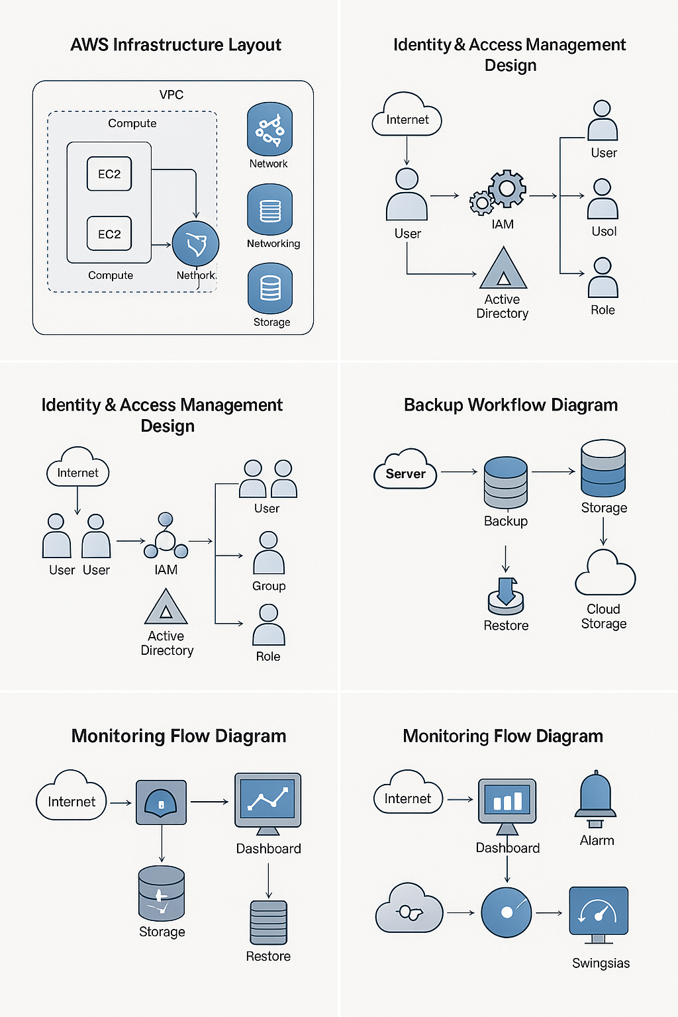

- AWS Infrastructure Layout
- Azure Infrastructure Layout
- Identity & Access Management Design
- Backup Workflow Diagram
- Monitoring Flow Diagram

Appendix E – Scripts & Configuration Samples
- AWS CLI Commands
- Azure PowerShell Commands
- IAM Policy JSON Templates
- Backup Automation Snippets

AWS CLI Interface –

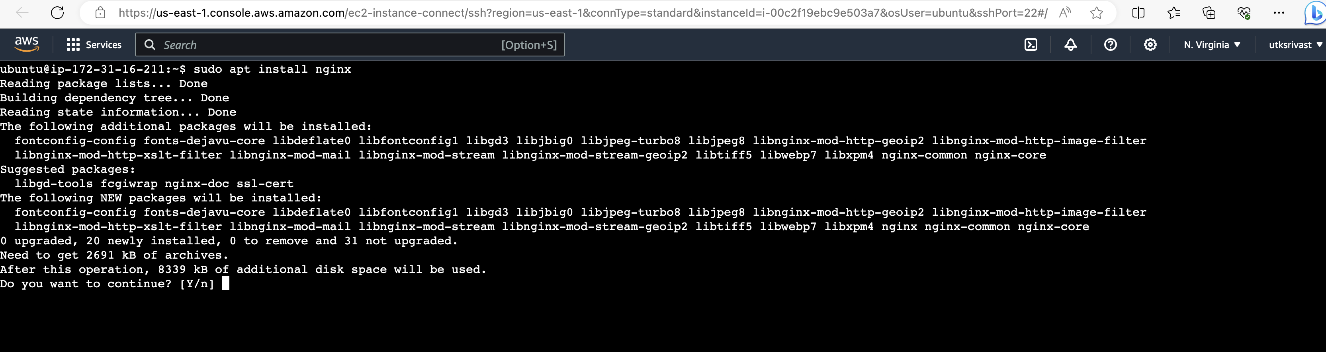

Appendix F – Screenshots
- AWS Management Console
- Azure Portal
- EC2 / VM Configuration
- S3 / Blob Storage Setup
- CloudWatch / Azure Monitor dashboards

EC2
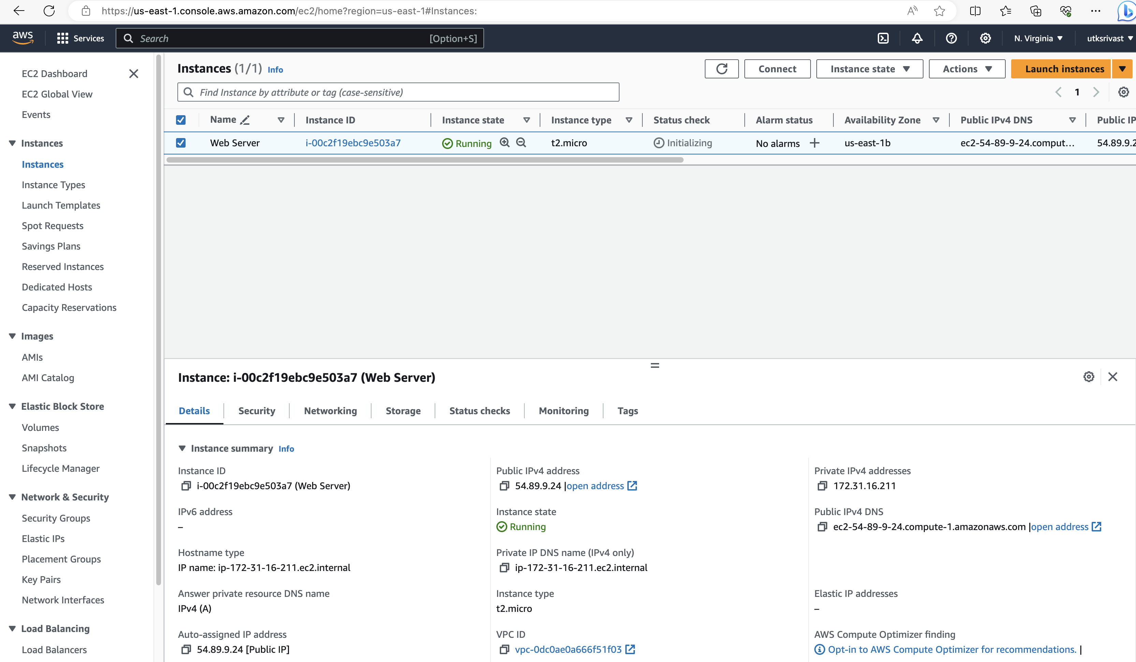

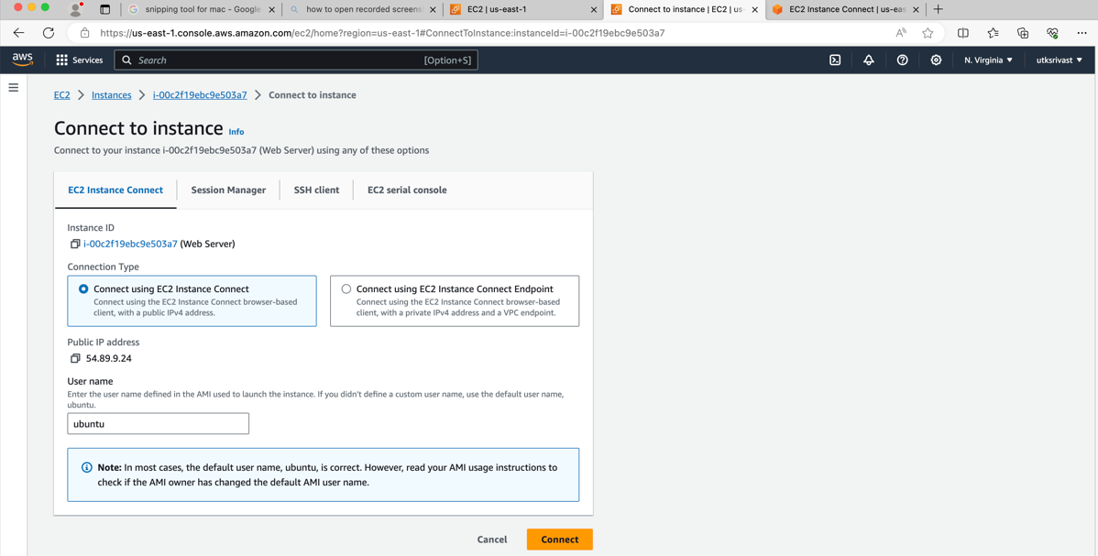

References
- Amazon Web Services (AWS) Documentation
Amazon Web Services. (2024). AWS Cloud Computing Documentation.
Retrieved from: https://docs.aws.amazon.com
- Microsoft Azure Documentation
Microsoft Corporation. (2024). Azure Cloud Services Documentation.
Retrieved from: https://learn.microsoft.com/azure
- AWS Well-Architected Framework
Amazon Web Services. (2023). AWS Well-Architected Framework – Best Practices.
Retrieved from: https://aws.amazon.com/architecture/well-architected
- Microsoft Azure Architecture Center
Microsoft Corporation. (2023). Azure Cloud Architecture Guide.
Retrieved from: https://learn.microsoft.com/azure/architecture
- Ansys Software Pvt. Ltd. – Internal IT Documentation
Ansys Software Pvt. Ltd. (2024). Cloud Infrastructure Support – Internal Operations Guide.
(Internal, not publicly accessible).
- Synopsys IT Infrastructure Guidelines
Synopsys Inc. (2024). Infrastructure & Security Policies.
(Internal organizational guidelines.)
- Cloud Computing Concepts
Mell, P., & Grance, T. (NIST). (2011). The NIST Definition of Cloud Computing.
Retrieved from: https://nvlpubs.nist.gov/nistpubs
- Cloud Security Alliance (CSA)
Cloud Security Alliance. (2023). Best Practices for Cloud Security and Compliance.
Retrieved from: https://cloudsecurityalliance.org
- YouTube / Cloud Tutorials Used for Learning
- AWS Tutorials for Beginners – FreeCodeCamp
- Azure Administrator Training – Microsoft Learn Videos

